

Ako ki te Haere – Haere ki to Ako

Learn to Journey – Journey to Learn

Kindness - Atawhai ● Excellence - Hiranga ● Respect - Whakaute ● Integrity - Ngākau pono

Mission Statement
“To actively prepare each child to take responsibility for their own life-long learning, values and behaviour, in partnership with the home and community.”



Silverdale School Board/Poari
NEWSLETTER

14th September 2022

Kia ora Parents, Caregivers, Students and Staff,

We would like to thank all the candidates for putting their names forward for the Silverdale School Board Triennial Elections. Please see the results below:
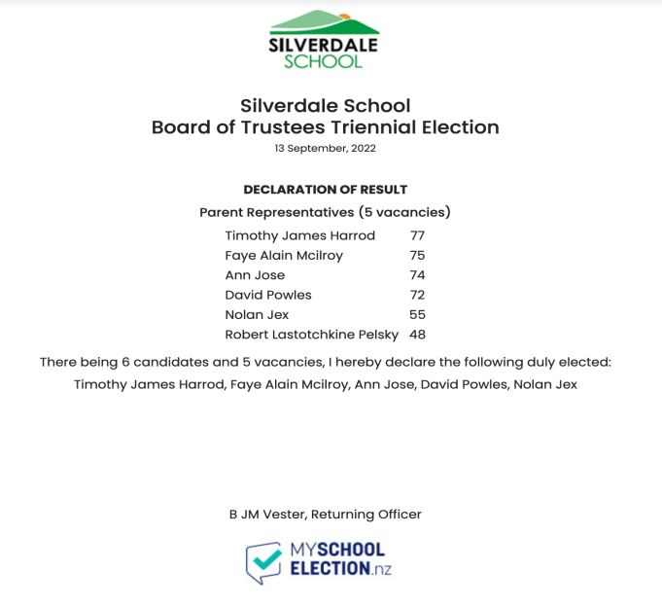

We would like to introduce you to the new Silverdale School Board 2022 - 2025

Parent Representatives







Timothy Harrod Faye McIlroy Ann Jose David Powles Nolan Jax

Staff Representative Principal

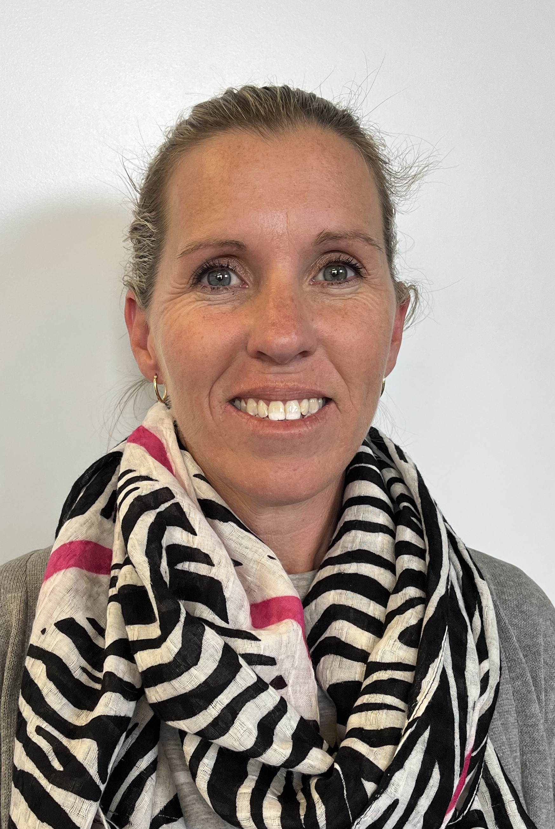

Donna Kitching Cameron Lockie

I would like to take this opportunity to thank the following people for all their time, professionalism, dedication and support they have given the school while they were on the School Board:

Hayley Thow (6 years)
Nicola Kayes (6 years)
Steven McCleery (5 years)
Megan Catterall (3 years)
Mark Ralston (3 Years)

This will be my last Silverdale School Board Newsletter; I have been on the Silverdale School Board for just over 14 years. I have seen the school grow from 150 students and 12 classrooms to what it is today, and it has been an absolute pleasure working along side all the people that have been on the Board with me over the years, the staff, the students and the community at Silverdale School.
I would especially like to thank Cameron Lockie our Principal, his vision, professionalism and dedication to our school is amazing, working with him to make our school what it is today makes me very proud to say I have been a part of it all.

Arohanui
Alison Gilchrist
Retiring Presiding Member
Silverdale School Board

